Perspective Hallway Drawing (SPI #5) Name: period:
Ms. Grunt PA standard 9.1.A, B, C, E, H; 9.3. A, B
Goal: In this project you will practice sighting to draw interior spaces. We will work in various parts of the room and hallways near the art rooms. You will aim to accurately draw a scene that captures correct proportions of the building in an interesting composition. The view must include a piece of floor, wall and ceiling. This project will further develop your ability to use plumb and level lines, sight angles and take comparative measurements.
Directions:
Using plexi-glass and a viewfinder, determine a composition you like, along with a unit of measurement. Draw this in your first thumbnail sketch. As you draw, use pencil and make light pencil marks. Instead of erasing, simply make a new mark, letting the others show through. In this way you can see each error and avoid repeating it. These ‘ghost lines’ help you find shapes that align with nearby forms.
Practice drawing a section of the classroom. A corner is a good place to start. Establish plumb lines and your eye level. Sight angles to place in your drawing (remember: think of windshield and windshield wipers).
Practice a second study of the classroom in your journal. Use sighting and your pencil as a tool for comparison measuring; practice finding correct proportions and angles on your paper. Find an object to be a unit of measure (write what you chose somewhere on your paper), and use this to compare sizes of other objects. Remember to also use plumb and level lines to line up elements in your view. You must use a viewfinder for this project!
Next, you may be able to work in the adjacent art room and/or hallway; scope out several views that interest you. Pick a place that is not blocking the view of classmates (first come, first serve). Determine that you are not blocking doorways for others, and that you can set up an easel or clipboard with relative ease. Using your view finder, make at least three thumbnails proportional for a piece of 18 x 24” paper; check with teacher to select strongest composition.
Using pencil, lightly divide paper into four quadrants, and do the same for your thumbnail. This will roughly help you gauge where to place things on the large paper. It is often helpful to note what is close to the center of the strings on your view finder, and start with this in the center of your drawing. Using ghost lines, determine placement of unit of measure and then begin to draw in major walls, floor and ceiling. Check your work. Do angles seem correct? Use your pencil to judge.
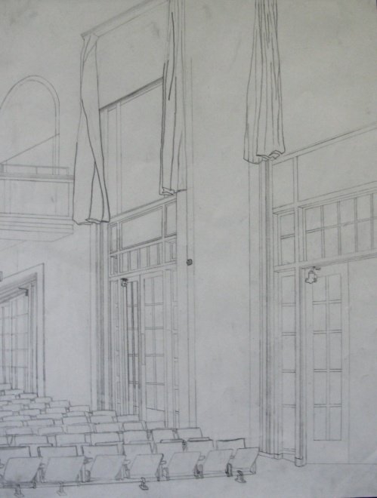
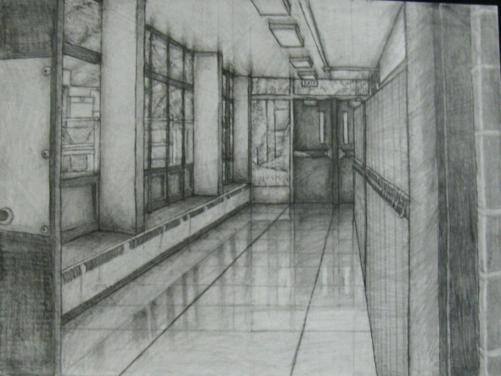

James Thompson, class of 2010 (left), and Rodney McCaulley, class of 2009 (right), created these perspective views of various parts of Penn Wood.

Assessment for SPI #5 Perspective Hallway Drawing Name_______________________period____
Note: late work is marked down unless you have enough makeup class time recorded below; to improve final grade, speak with me. Date Due___________ Date turning in________________ Record dates of makeup time:___________________

Fill points in boxes “S” (student), “P” (peer), “T” (teacher): 1 = evident; ½ = partially evident ; 0 = not evident
S P T concept 9.1.A; 9.3 A, B comments
 |  |  | ● Is a unit of measure established as you begin your drawing? Include a sketch and explanation of where /what your unit of measure is in box on right. | Title for your work: _______________  describe Unit of Measure:
 |  |  | ● Accurate/convincing sighting of angles in your work evident throughout
 |  |  | ● Comparison Paragraph clearly explains 3 significant similarities and differences between your work and the piece you select for comparing.
 |  |  | ● Comparison paragraph uses accurate comparison structure as provided in handout including transition words and accurate grammar.
/4 | /4 | /4 | = total concept points out of 4
craftsmanship 9.1. B, H
 |  |  | ● Are plumb lines true verticals in the work? Is eye level correctly established? | S
 |  |  | ● Are proportions well-measured relative to each other so that objects look accurate when gauged against other objects in your picture?
 |  |  | ● Do lines/ edges stand apart from background so piece is clearly readable (not too light)? | T
 |  |  | ● Work shows overall care and completeness in use of materials
/4 | /4 | /4 | = total craftsmanship points out of 4
composition 9.1. C, E
 |  |  | ● Does drawing fill entire page while including view selected with angles (not just plumb and level lines)? | S
 |  |  | ● Does view include a corner and a piece of the floor and ceiling?
 |  |  | ● Does composition consider the use of thoughtful composition choices regarding interesting negative space (not too much empty space)? | T
 |  |  | ● Does composition successfully employ techniques such as ‘smart cropping’, overlapping and other techniques on “Smart” handout?
/4 | /4 | /4 | = total composition points out of 4

 |  |  | Total concept | 12 = 100%  11.5 = 96%  11 = 92%  A  Exceeds expectations | 10.5 = 88%  10 = 83%  B  Meets expectations | 9.5 = 79%  9 = 75%  8.5 = 71%  C  Meets most expectations | 8 = 67%  7.5 = 63%  D  Some evidence of expectations | 7 and below= failing  F  Little to no evidence
 |  |  | Total craftsmanship
 |  |  | Total composition
/12 | /12 | /12 | Late work grade reduced____ =
9.1.A Know and Use elements and principles of art; 9.1.B Apply appropriate arts elements and principles to produce and revise original work; 9.1.C Integrate and apply advanced vocabulary to the arts
9.1.E Delineate a unifying theme through the production of a work of art that reflects skills in media processes and techniques.
9.1.H Incorporate effective and safe use of materials.

Name____________________________ Period _____ Date ____________
Ms. Grunt
PA standards: 9.3 Critical Response (9.3.12.A:Explain and apply the critical examination processes of works in the arts and humanities, 9.3.12.B: Determine and apply criteria to a person’s work and works of others in the arts)

Artist Study (SPI #5 Perspective Hallway) by Johannes Vermeer, Emanuel de Witte, Charles Sheeler and Vincent Van Gogh
Open Project 3 Images on the class website (msgrunt.com Studio Portfolio I) under Images for Paragraph. Select an image that you want to compare to your project. In the box below, draw a sketch of image you are selecting (note: draw a vertical border inside it if it is vertical composition).

Artist _____________________
Title______________________

Date______________________
Compare the image you’ve selected to your project. From the following list consider what is similar and what is different. Write an “S” or “D” next to each:
___Use of accurate sighting
___Accurate (realistic) proportions
___Type of shading (hatch marks, other)
___ Range of value on value scale ( 1 – 8)
___Use of overlapping
___ Amount of distance (depth) achieved (shallow or far)
___Compositional choices (overlapping, cropping, unusual view point, etc.)
___ Evidence of accurate use of plumb lines to aid in drawing
___ Subject matter (ie: architectural elements in the works, columns, bricks windows, etc.)
Complete a TYPED well-written paragraph in which you argue that despite differences (discuss 3), the two pieces actually share important similarities (discuss 3). Conversely, you may choose to argue that despite similarities the pieces are actually different, following the same format. Note, this means that you will give examples of each similarity and difference you describe. Push yourself to find thoughtful and interesting similarities and differences as opposed to obvious statements like ‘each piece shows perspective’.

Check off each item below:
___● paragraph is submitted by the deadline (note: late paragraphs won’t be accepted!).
___● Image is sketched above
___● Paragraph introduces full name of artist in opening sentence
___● Titles of the artwork being discussed are italicized and CAPITALIZED!
___● Thesis is stated (in 1st or 2nd sentence) (Several difference and similarities are apparent when comparing _____________’s (insert title) with my ______________ (project name, media).
___● 3 similarities are well explained
___● 3 differences are well explained
___●Variety of transition words are used (and underlined) to discuss and explain list of similarities and differences (use transition-word handout!)
___● A transition sentence is included to change from the discussion of differences to the discussion of similarities (it is also underlined) ex: Despite these differences there are also several important similarities between these pieces of artwork.
___● Finally, conclude the paragraph, by including your opinion about the works discussed (see sample).

